INTEGRATIVE COURSE IN PSYCHOLOGY (ICOPSYCH)

ANALYSIS ON THE RESULT OF POST-TEST EXAMINATION IN DEVELOPMENTAL PSYCHOLOGY
MAY 3, 2025

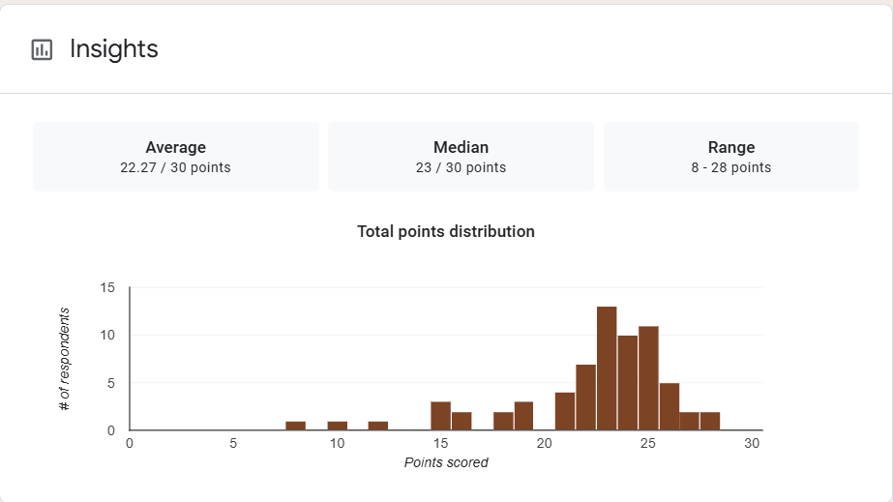

1. Mean Score: The mean score of 22.27 out of 30 equals approximately 74.2%, which indicates a relatively strong average performance by the students. This suggests that the majority understood the material fairly well or that the test was appropriately designed for the group’s skill level.

2. Median Score: The median score of 23 (76.7%) is slightly higher than the mean. This implies a slight negative skew, meaning that most students scored around or above the average, but a few low scores brought the mean down slightly.

3. Range: The range spans from 8 to 28, giving a spread of 20 points. This indicates a moderate to high variability in performance. While some students scored very low (26.7%), the top performers reached up to 93.3%, showing a strong grasp of the material.

Interpretation Summary:

-Students, on average, performed well on the exam (74.2%), with the majority scoring near or above this average (median = 76.7%).

-The slight negative skew suggests a few outliers on the lower end affected the mean.

-The range of scores (8–28) indicates some variability in understanding, but the strong upper end performance shows many students had a solid command of the material.

-Overall, the exam results reflect good overall comprehension with a need for additional support for a small number of lower-performing students.

RATIONALIZATION:

DIFFICULT QUESTIONS:

